12 January 2007 The Weekly Bulletin of Rotary Club of Kathmandu Mid-Town Bc # 28 of 2006-07
Rotary Club of Kathmandu Mid-Town
Breakfast Chatter




District : 3290 Web: www.rotarymidtown.org.np Club Id : 26776

JANUARY IS ROTARY AWARENESS MONTH
Rotarians have the opportunity to – and must – create awareness among the public sector as well as the private sector regarding world problems and how they can be solved through cooperation and continuity.

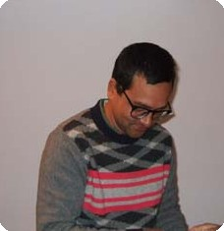
Guest Speaker Dr Pratyoush Onta provided a presentation on role of intermediate organisations in socio-economic transformation in the country at the Club meeting on 5 Jan 2007. His question on why status quo persists remained un-answered; he discussed some of its implications in the socio-political life and shared his opinions with club members during interaction after his presentation.
◄ Dr Onta looking at the Letter of Appreciation after it was presented to him by IPP Komal Chitracar who presided over the meeting as President CK Golchha was on leave of absence.

Weekly Meetings and Programs :
Date | Program/Speaker | Program/Topics of Presentation
12 Jan 2007 | GSE Team | Presentation by GSE Team from Brazil
19 Jan 2007 | Ranjit Acharya | Personality development basics
26 Jan 2007 | Amanda Rader

Friday, 12 January :
Group Study Exchange team from Brazil comprising of 5 participants who arrived at Kathmandu on 9 January 2007 willl be providing their presentations during the Club meeting on 12 Jan 07.

Calendar 2007 Project
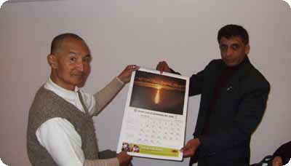

The Calendar 2007 project of the Club took shape.
IPP Komal Chitracar and Fund Raising Director Basu Dev Gautam jointly launched Calendar 2007.
Information Corner:
Low cost medicines :
Two UK-based academics - Sunil Shaunak, professor of infectious diseases at Imperial College, based at Hammersmith hospital in west London, and his colleague from the London School of Pharmacy, Steve Brocchini - have devised a way to invent new medicines and get them to market at a fraction of the cost charged by big drug companies, enabling millions in poor countries to be cured of infectious diseases and potentially slashing the UK health service's drugs bill.
They call their revolutionary new model 'ethical pharmaceuticals'. Improvements they devise to the molecular structure of an existing expensive drug turn it technically into a new medicine which is no longer under a 20-year patent to multinational drug company and can be made and sold cheaply. The process has the potential to undermine the monopoly of the big drug companies and bring cheaper drugs not only to poor countries but back to the UK
Prof Shaunak and Steve Brocchini have linked up with an Indian biotech company which will manufacture the first drug - for hepatitis C - if clinical trials in India, sponsored by the Indian government, are succesful. Once the drugs have passed through clinical trials and have been licensed in India, the same data could be used to obtain a European licence so that they could be sold to the UK health service as well.
Imperial College will hold the patent on the hepatitis C drug to prevent anybody attempting to block its development.

Former UN Secretary-General Kofi Annan :
“Rotary is living proof that people with diverse backgrounds can learn to get along with each other and concentrate more on the things we have in common, rather than on the things that drive us apart.”

On Lighter Side : Click at the figure ⇩


Rotary is about service and putting Service Above Self. Rotary was founded for fellowship, but it quickly grew into an organization where people who wanted to serve others came together to do it – better, more effectively, and more enjoyably than they could have alone. We’re members of our clubs so we can work through them to help others. That is why we’re Rotarians.
RI President William B. Boyd

12 January 2007 The Weekly Bulletin of Rotary Club of Kathmandu Mid-Town Bc # 28 of 2006-07

Editor: RR Shrestha, Club Service Director email: rryes@wlink.com.np

